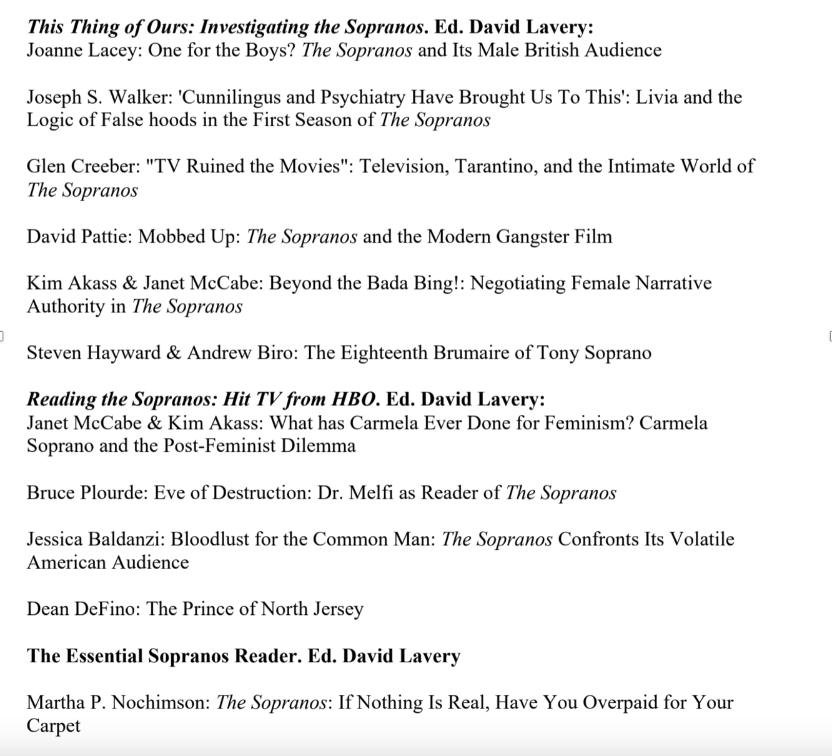

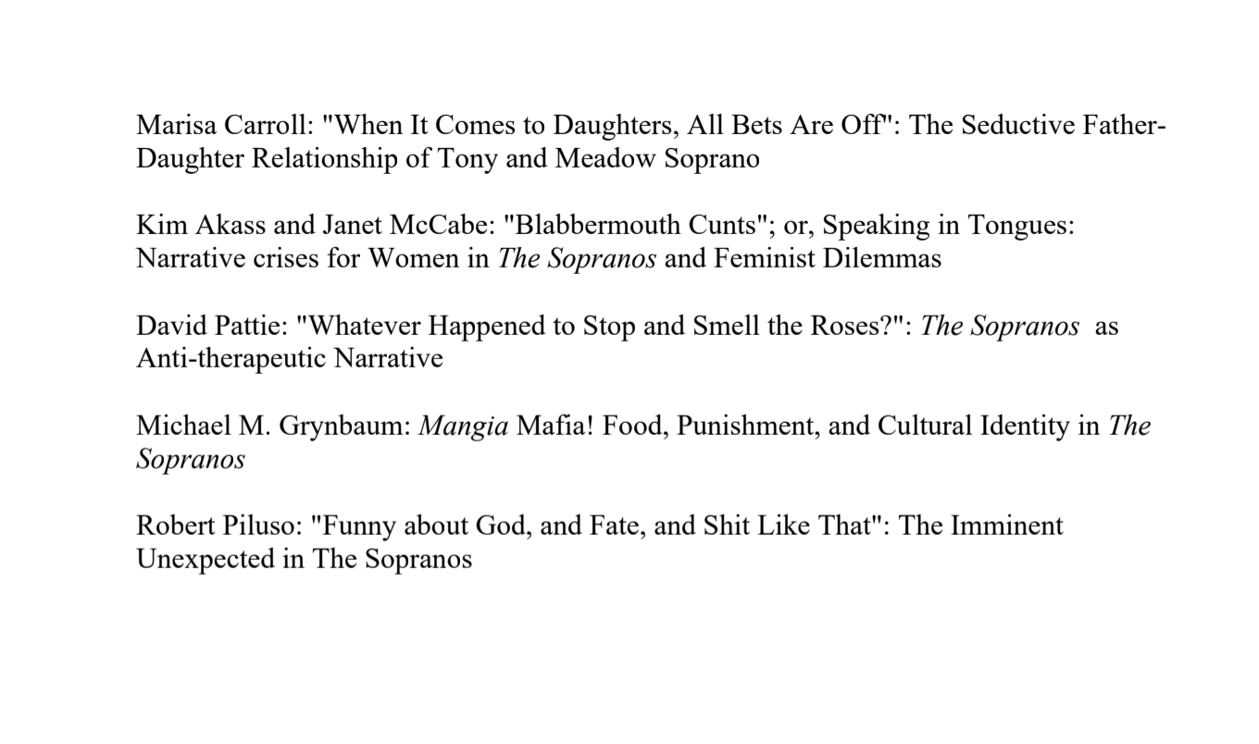

THE ABOVE PHOTOS ARE SOURCES/ARTICLES TO USE TO HELP ASSIST IN THE ESSAY.

THE BELOW PHOTO ARE EPISODE TITLES THAT YOU CAN WATCH TO HELP ASSIST WITH THE ESSAY.

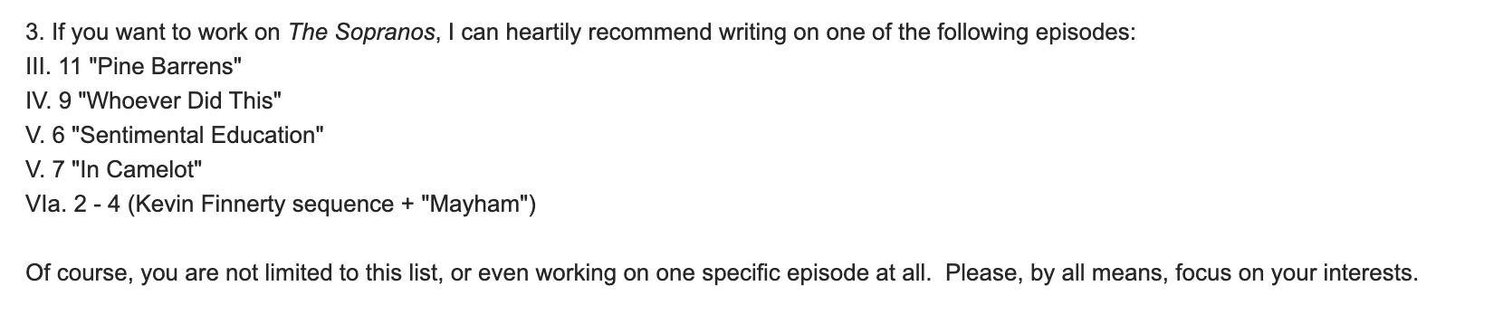

INSTRUCTIONS:
10-12 page essay. Double spaced. 12font. The usual.

